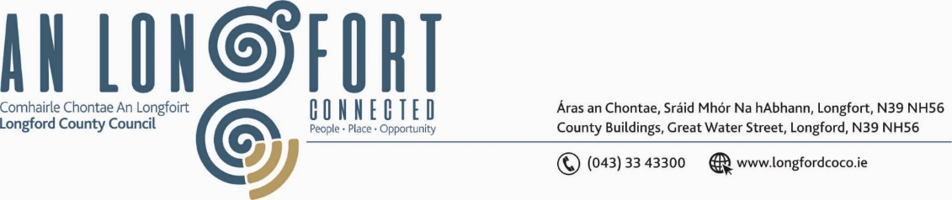

**GRANARD MUNICIPAL DISTRICT**

***Please note meeting will be held in Granard Library.***

**8th October 2021.**

**To: Each Member of Granard Municipal District.**

**Dear Member,**

You are requested to attend a Committee Meeting of Granard Municipal District to be held in

**Granard Library** on **Thursday 14th October 2021 at 2.30pm** to transact business, as set out on the Agenda hereunder.

**Yours sincerely**,

Ann Marie Mc Keon

______________________

**Ann Marie Mc Keon,**

**Meetings Administrator.**

**AGENDA**

**1.** Chief Executive Report - Material Alterations Consultation phase.

**2.** Consideration of applications for funding under the 2021 Community Grant Support

Scheme – list enclosed.

**3.** Special Projects Funding / Discretionary Grants 2021 - list enclosed.